Made in Madley 2023
Craft Workshop Day
Am 9.30 – 1.30 (4 hours) Morning Workshops are £20 inc. Workshop materials
Heart Shaped folding Needlecase  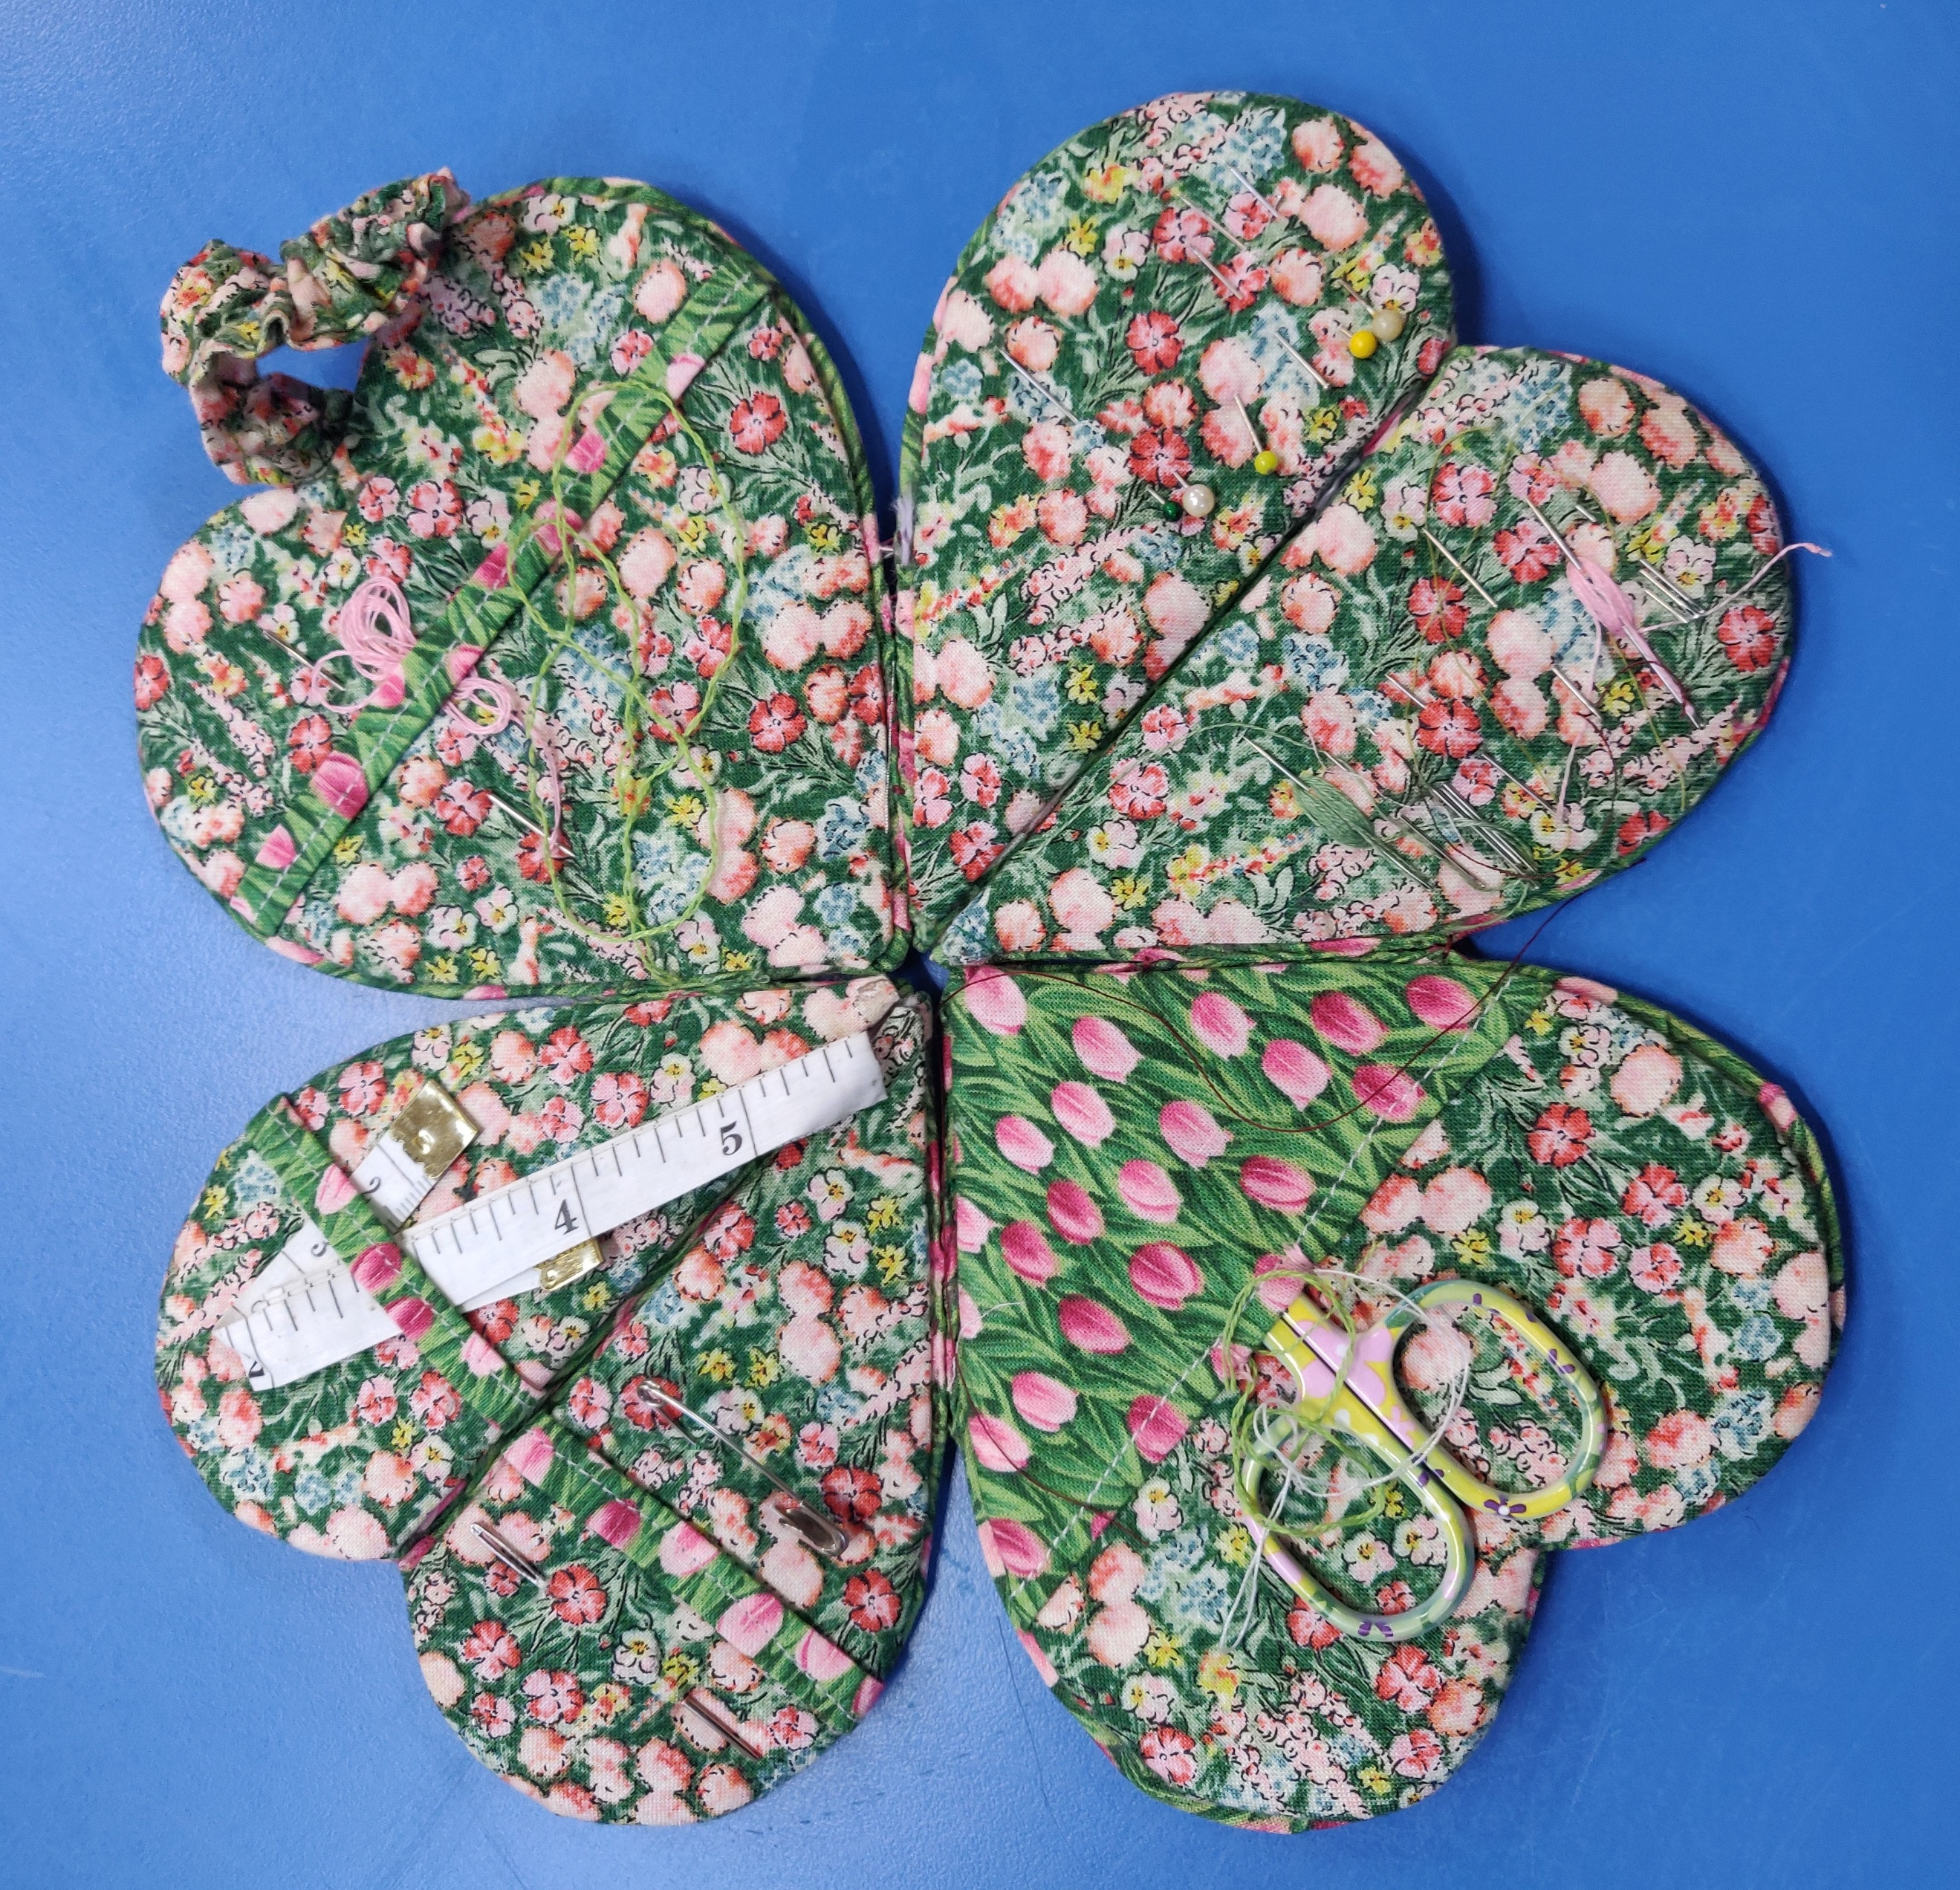 | Fabric Coiled Bowl  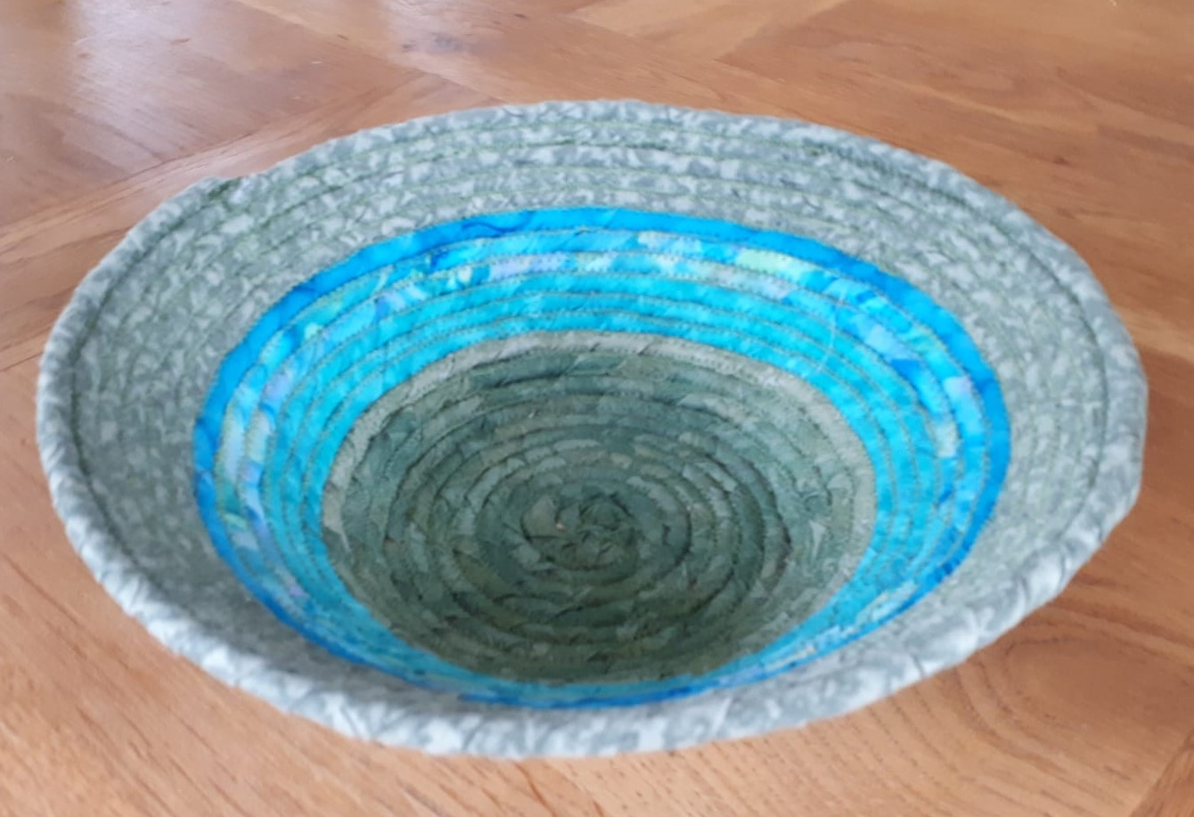  Sewing Machine Required | Blackwork Embroidery  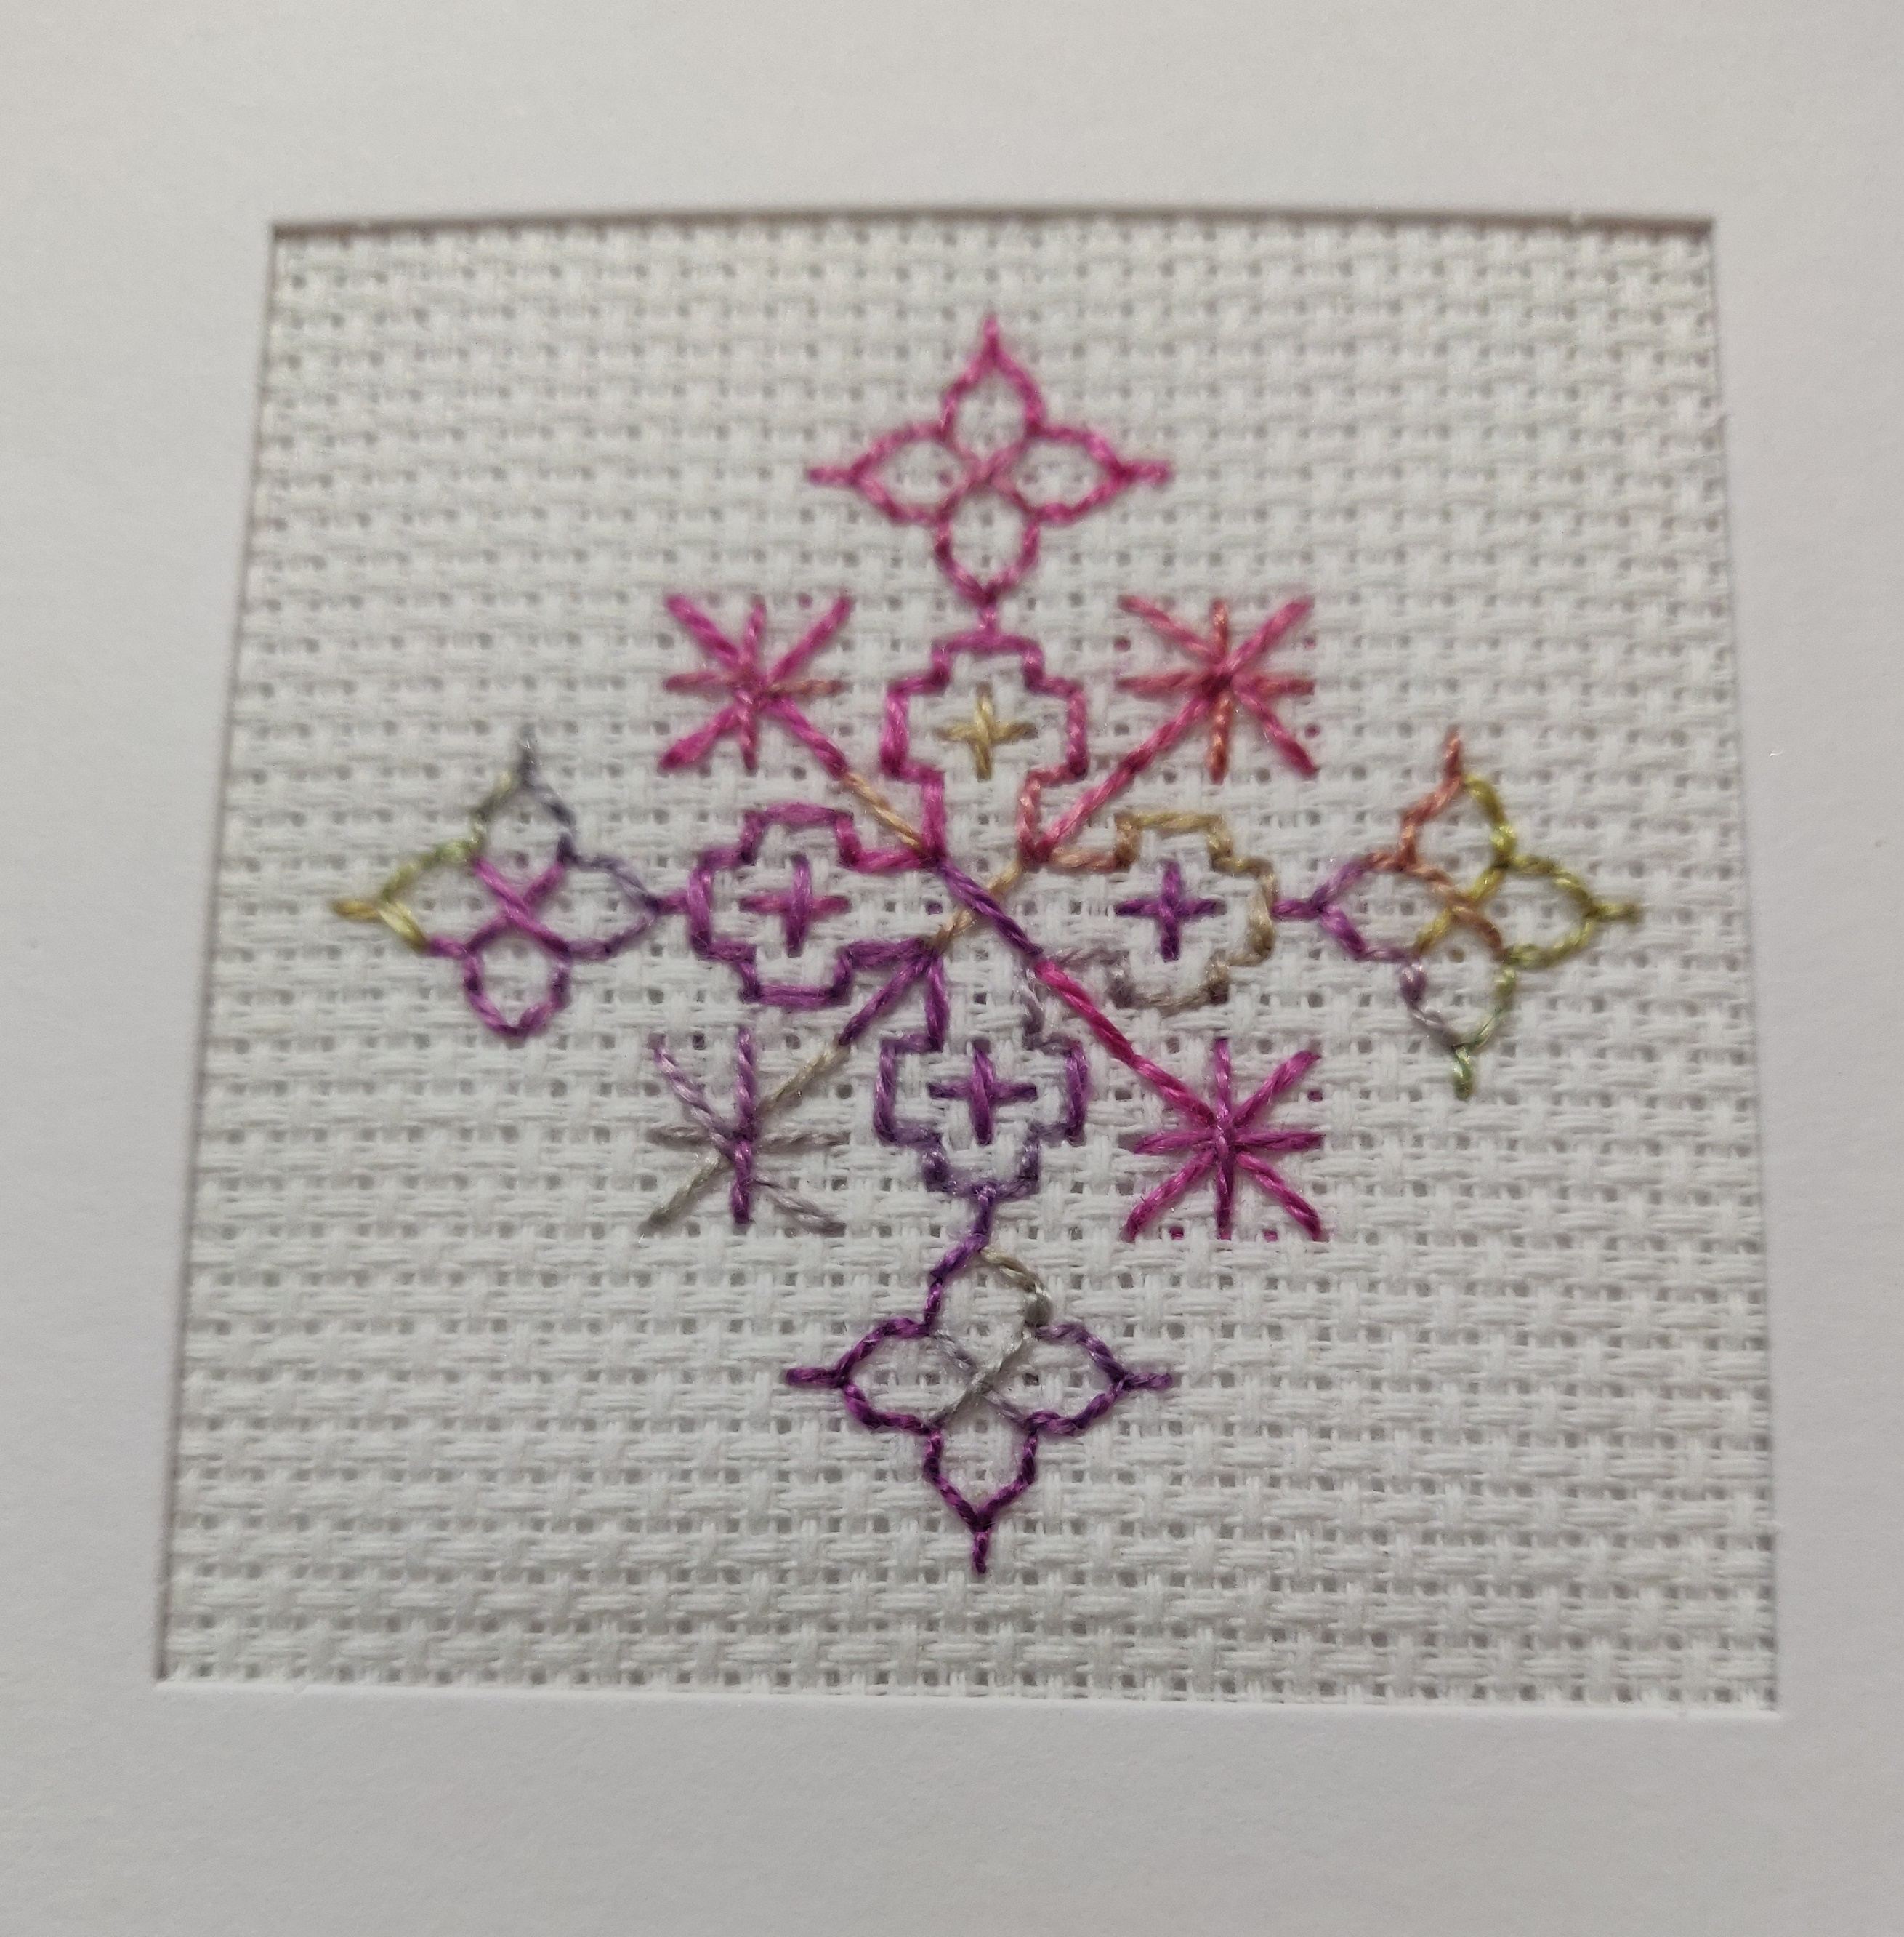
Needle Felted picture  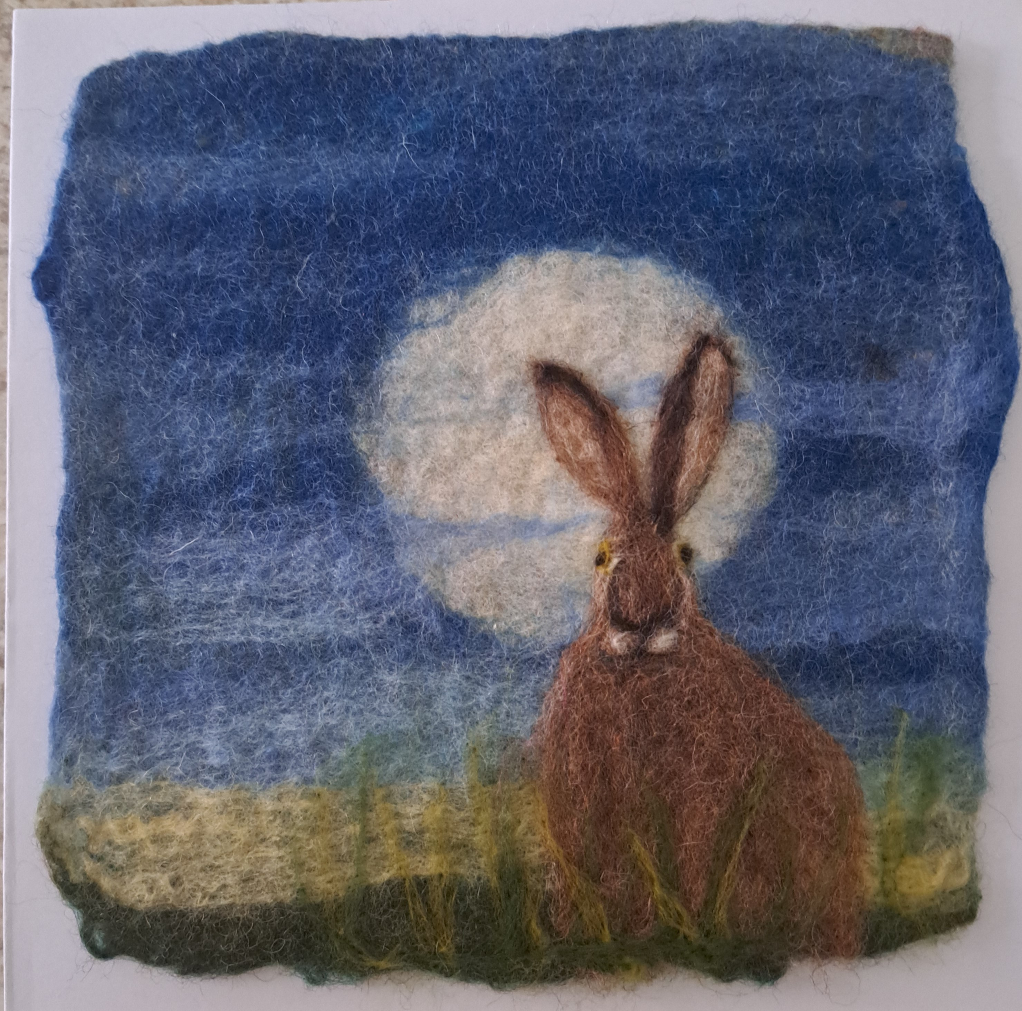 | Embroidered Serviette Ring  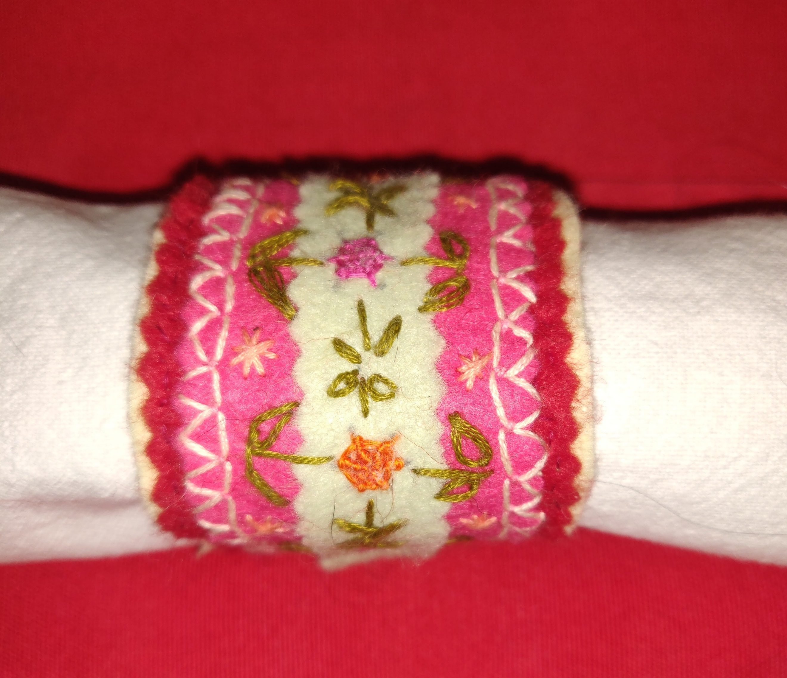 | Various Christmas Decorations & Boxes  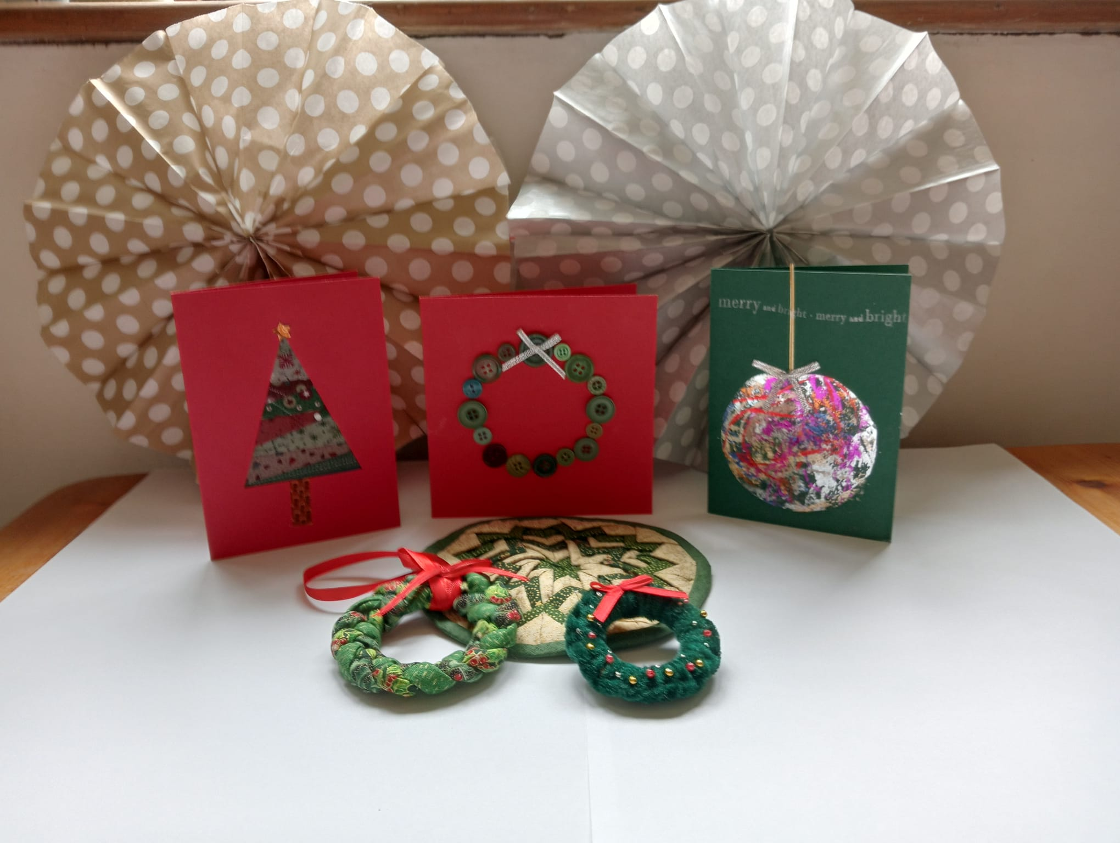
Pm 2.30 – 4.30 (2 hours) Afternoon Workshops are £10 inc. workshop materials
Ohmiyage Bag  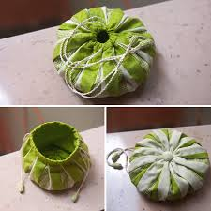  Sewing Machine Required | Fabric Pine cones  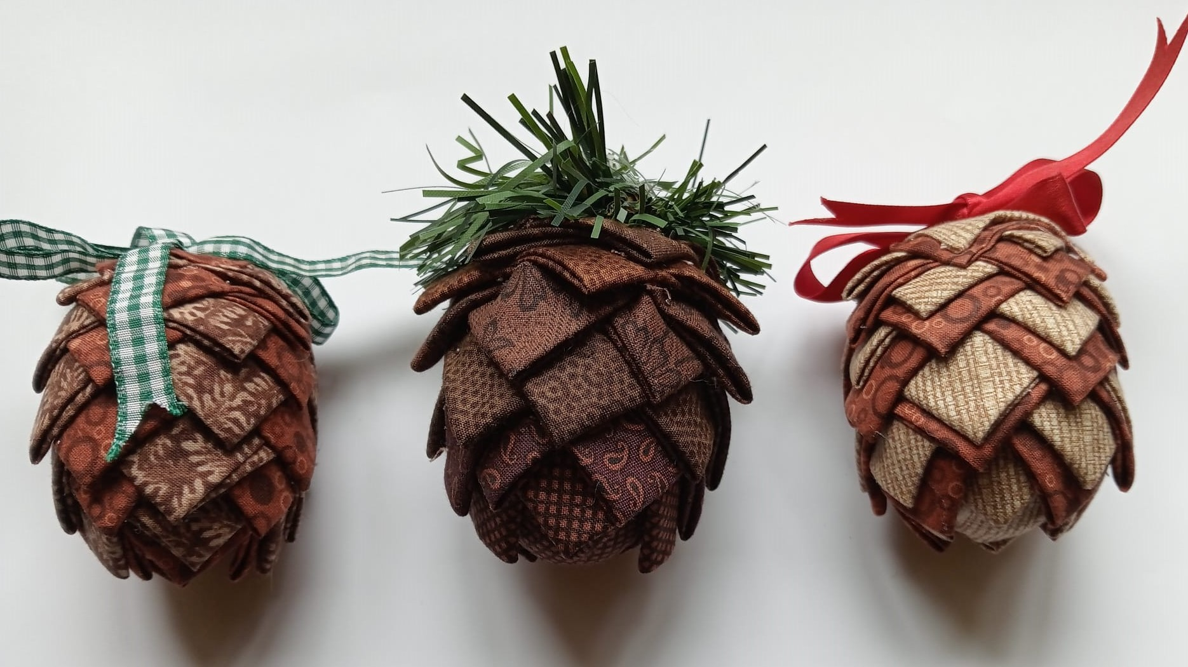 | The Art of Sashiko  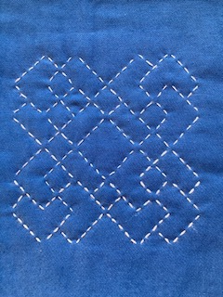
Macrame Wall Hanging  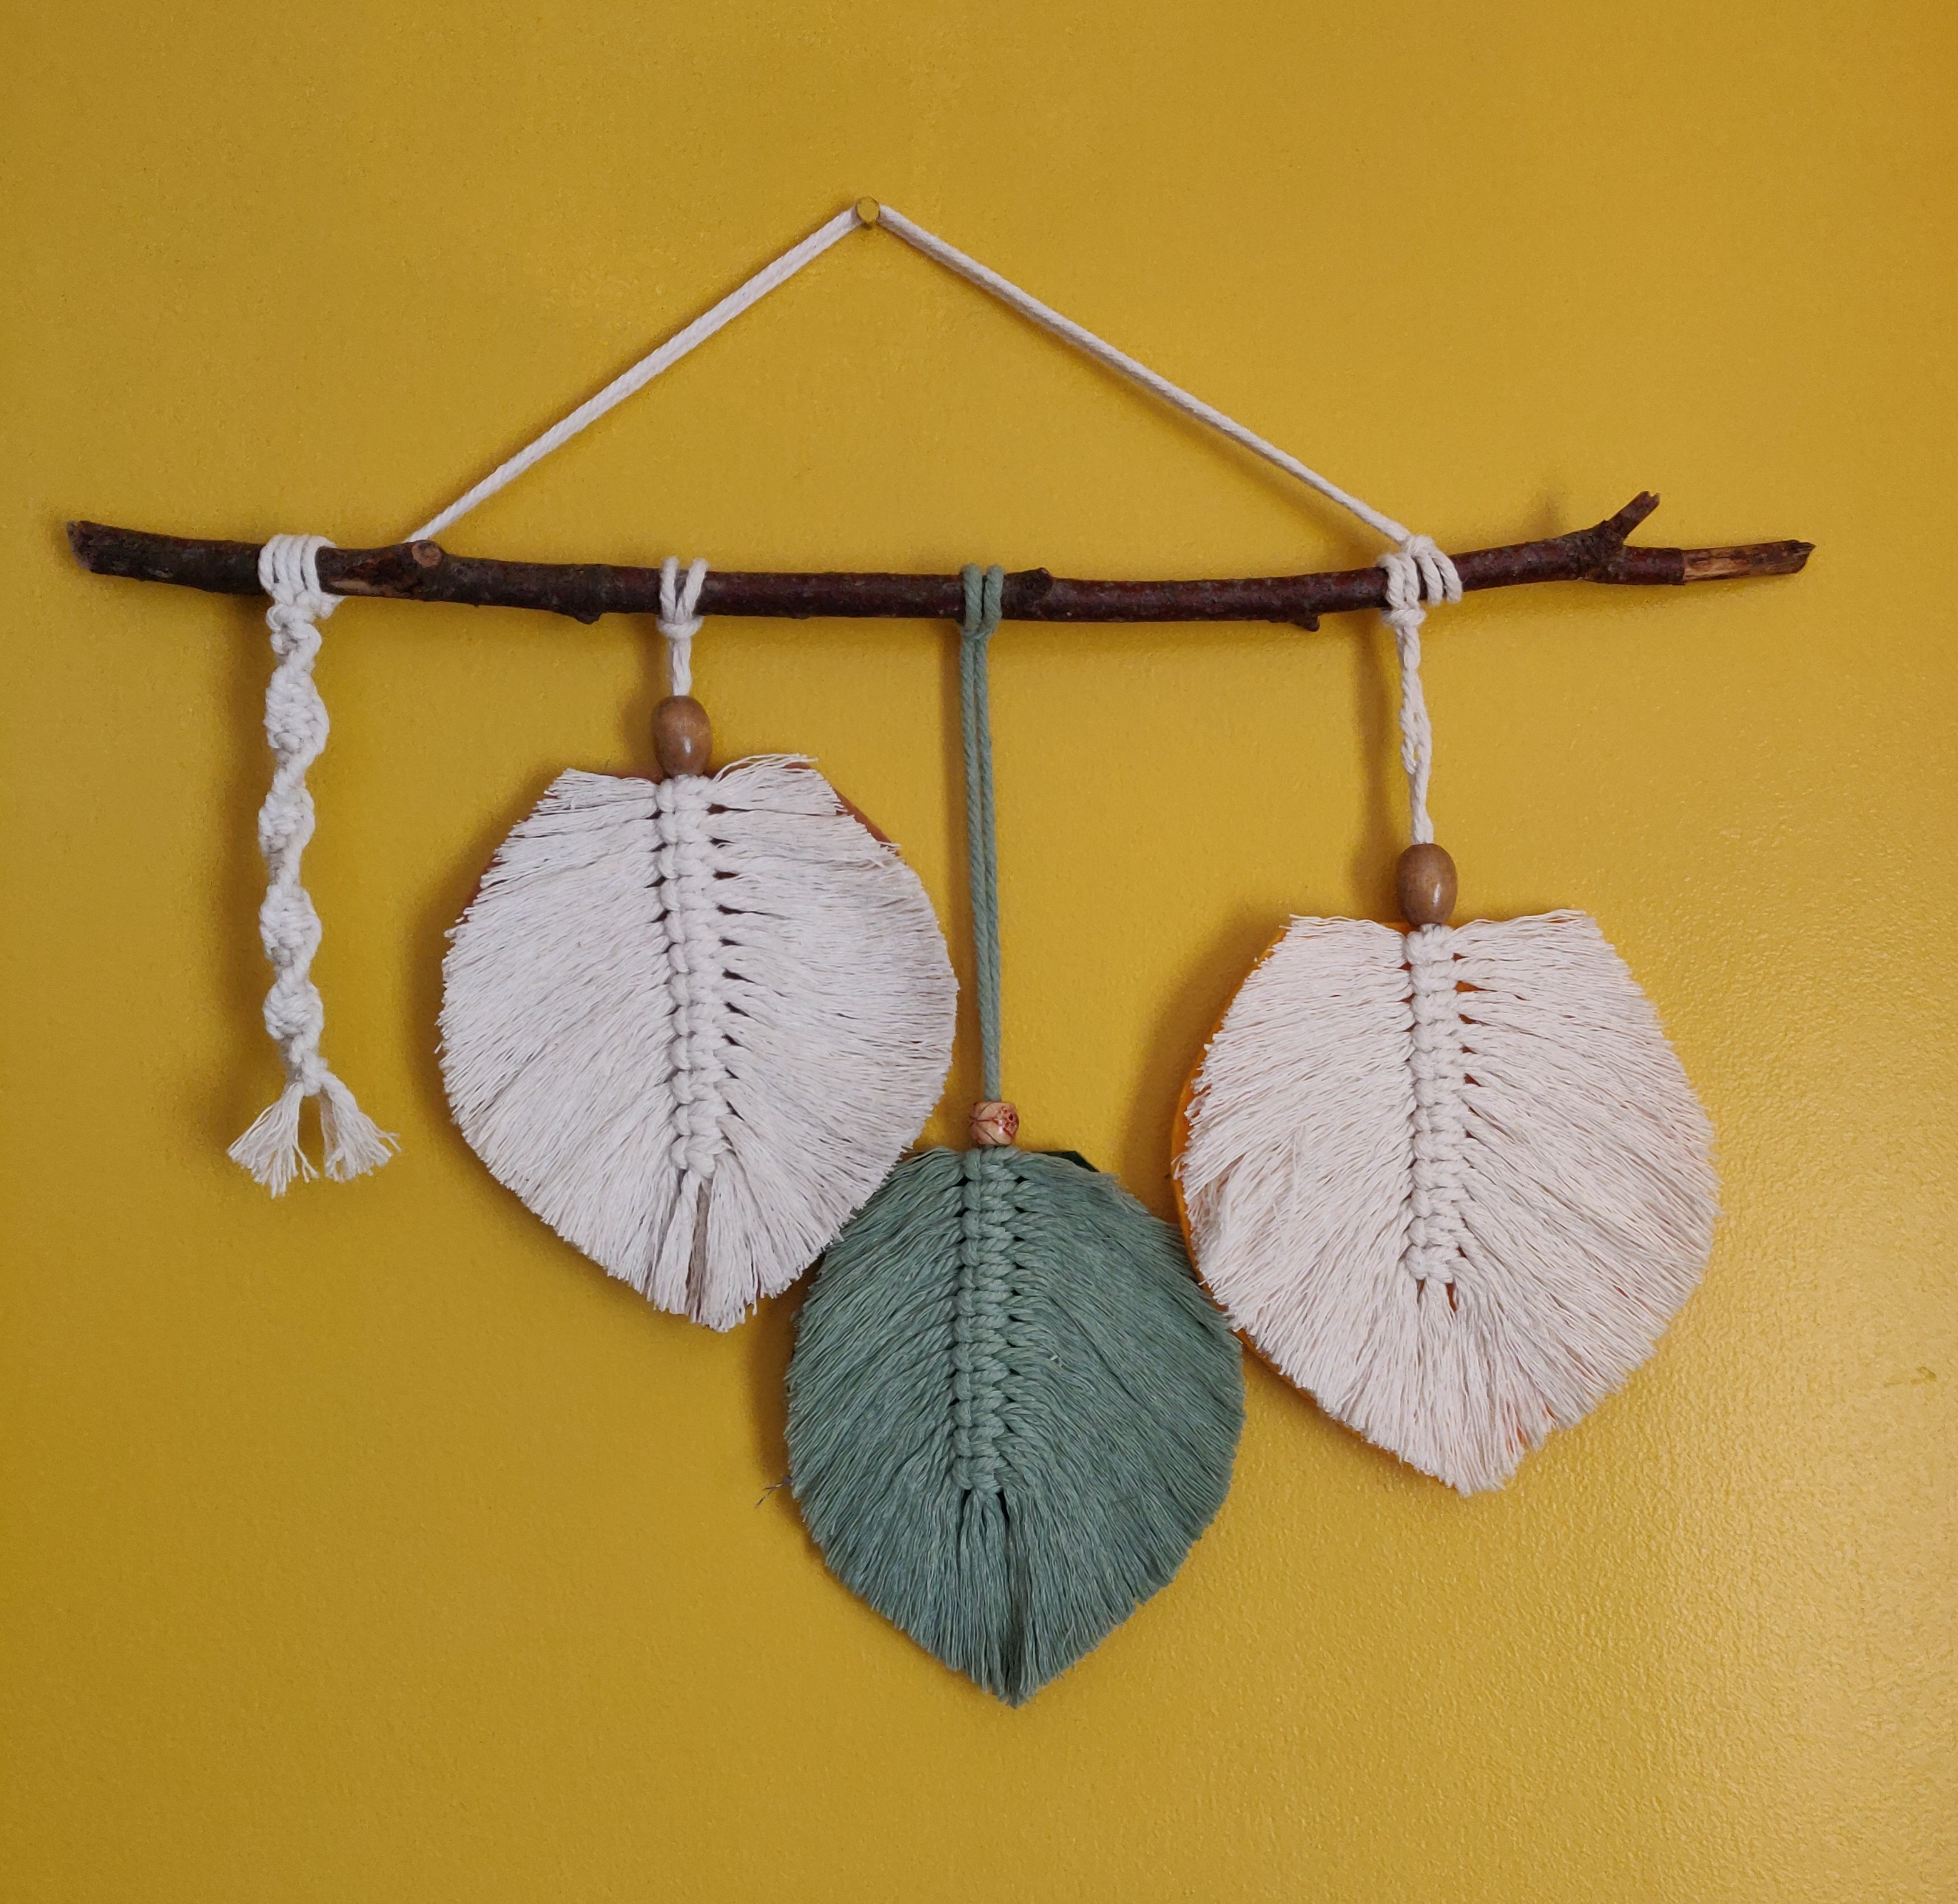 | Embroidered Decoration  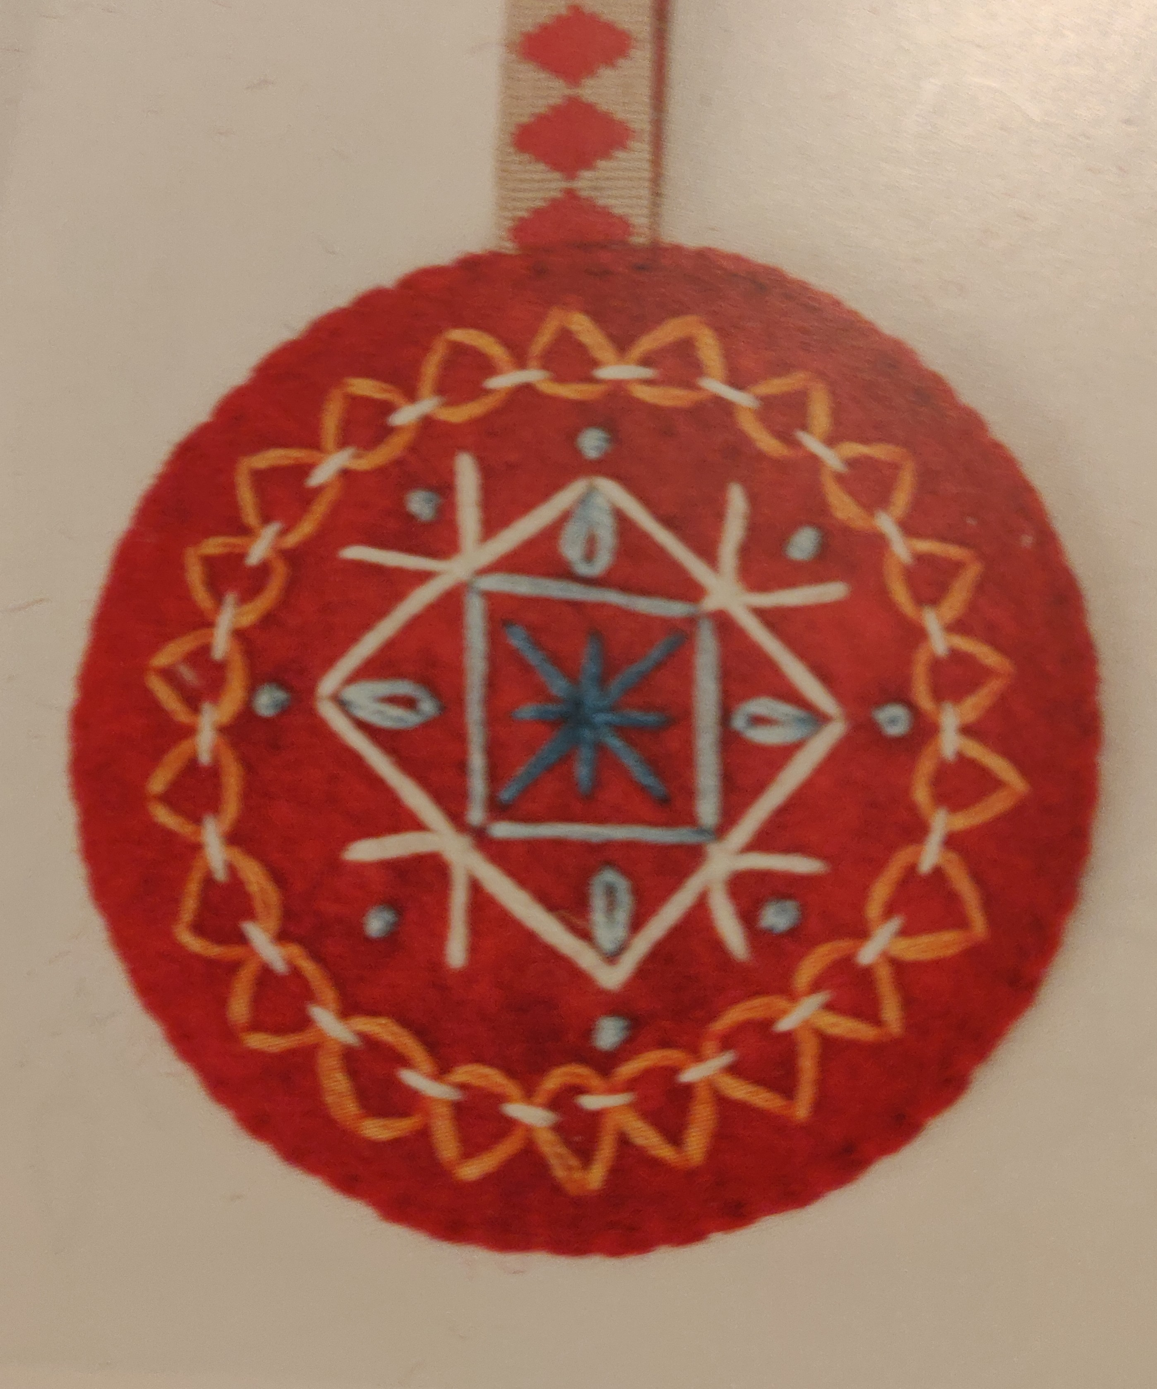 | Block Printed Tote Bag  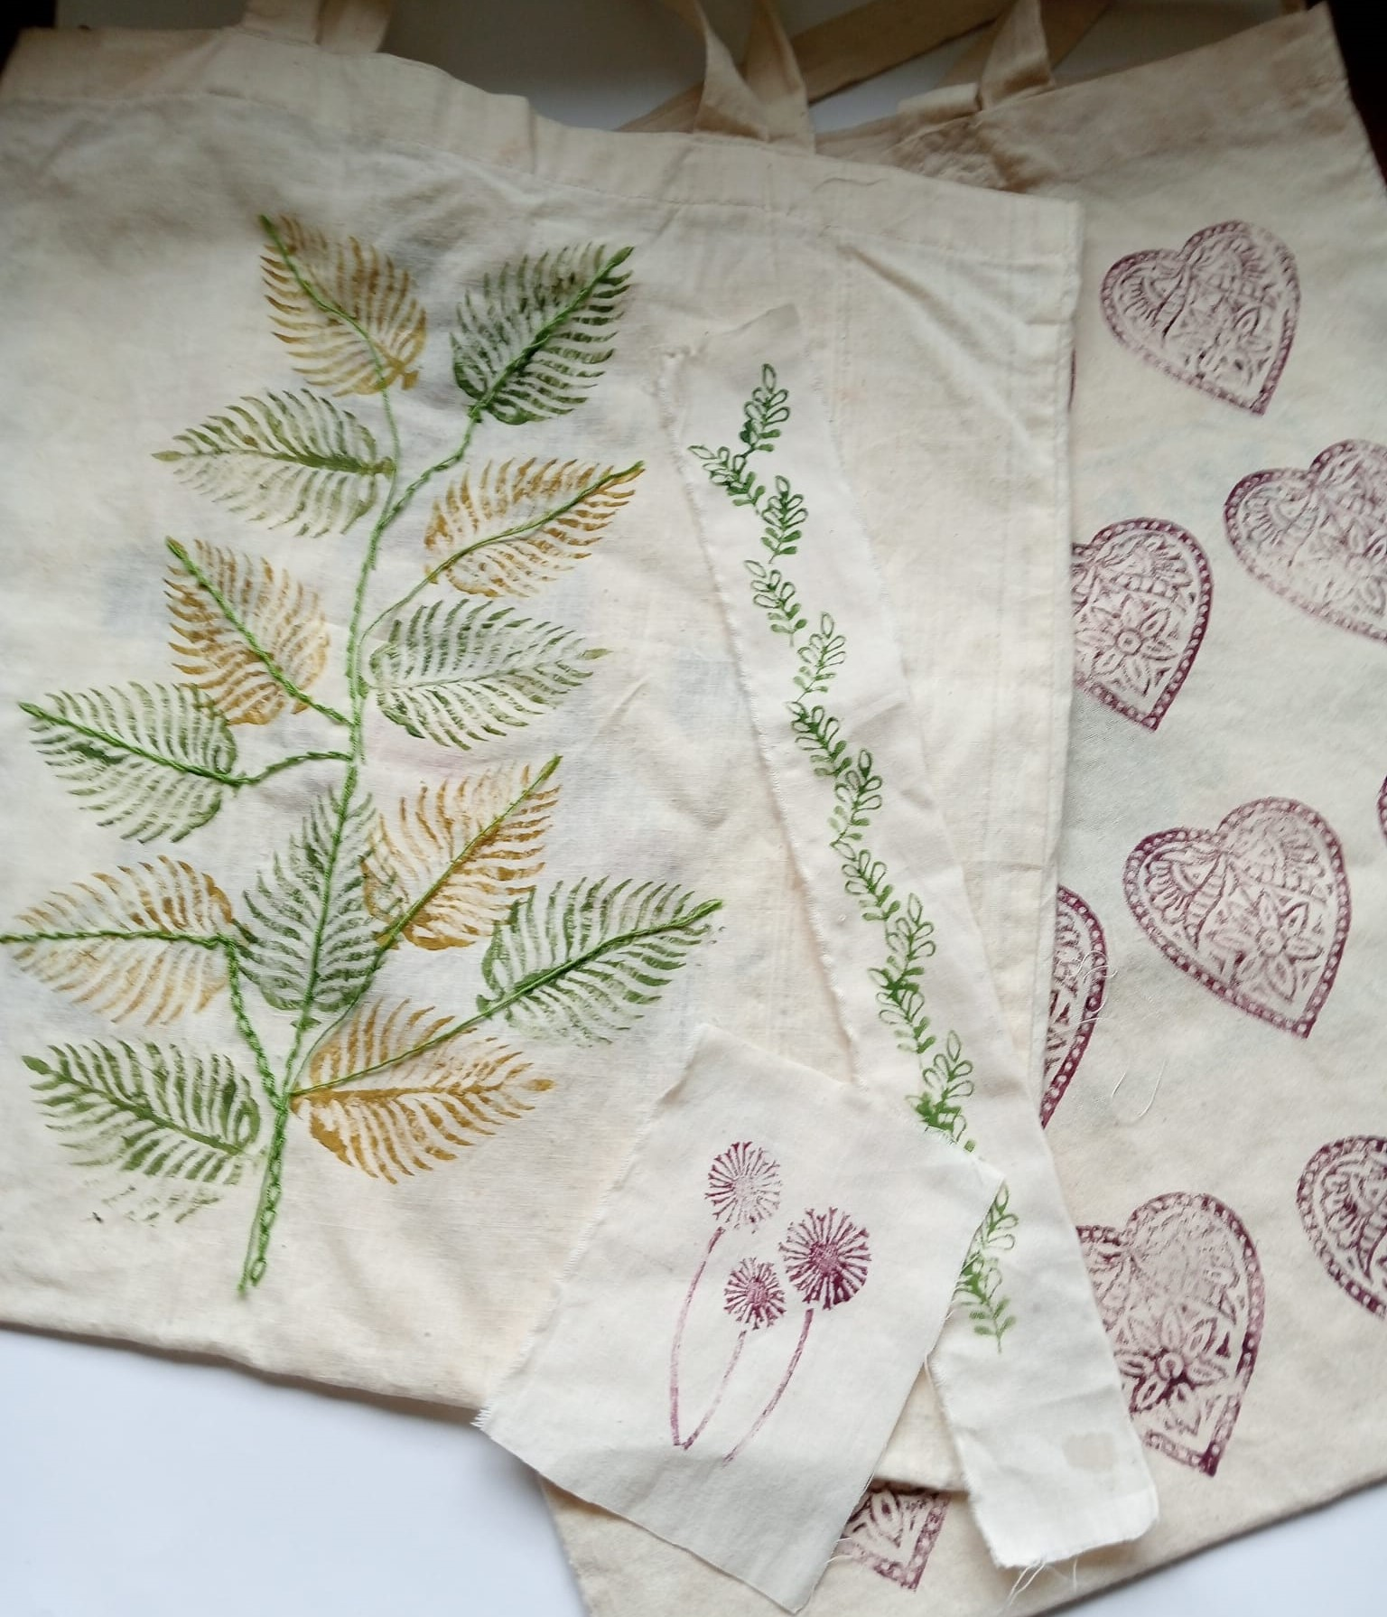
25th November 9.30 – 4.30
Madley Parish Hall HR2 9PH
Arrival / Tea from 8.45
Tea/Coffee/ light lunch available (not included)
Booking essential – places are limited. Payment is required when booking.
Book online Madley Craft Workshops or email Evelyn – ev@corco.co.uk or ring 07986 650060

